IoT AC Power Dimmer
with ESP32 + ESP-NOW Wireless Remote
Project Design Document | March 2026
Project Summary
A two-board wireless AC dimmer using ESP32 microcontrollers on both the dimmer and remote. The dimmer board connects to 230V mains and uses phase-angle TRIAC control. The remote runs on a 3.7V LiPo battery with USB-C charging via TP4056. Both boards communicate over ESP-NOW..

Parameter | Dimmer Board | Remote Board
MCU | ESP32-WROOM-32 (240MHz dual-core) | ESP32-WROOM-32 (240MHz dual-core)
Wireless | ESP-NOW RX + WiFi (simultaneous) | ESP-NOW TX only (on wakeup)
Power supply | HLK-PM03 (230V→5V direct) | 3.7V LiPo + TP4056
AC control | TLP281-4 + MOC3021 + BT138 | None
Max load | ~2000W (BT138 12A) | —
Phase timing | hw_timer_t Core 0 (hardware ISR) | —
Sleep current | ~120mA (PSU dominant) | ~5µA deep sleep
Battery life | — | ~4-6 months (500mAh LiPo)
Programming | USB-C via CP2102 on-board | USB-C via CP2102 on-board
Future expansion | MQTT over WiFi, OTA updates | BLE, display add-on possible

1. Project Overview
We will make both the ESPs communicate with each other and with the remote board’s instruction, the dimmer board will adjust the AC Supply.

2. System Architecture

2.1 Dimmer board block diagram
Block | Component | Function
AC IN | MKDSN 5.08mm screw terminal | Live + Neutral mains input
Isolated PSU | HLK-PM03 | 230V AC to 3.3V/900mA, isolated. No LDO needed.
ZC detector | TLP281-4 + R1 10kΩ + D1 1N4007 + R2 10kΩ pull-up | Detects mains zero crossings, outputs 3.3V pulses to GPIO34
Gate drive | MOC3021 + R3 330Ω | Optoisolated TRIAC gate trigger from GPIO25
Power switch | BT138-600 TRIAC + R4 470Ω gate + R5+C5 snubber | Controls AC power to load
MCU | ESP32-WROOM-32 | Core 0: phase timing. Core 1: WiFi + ESP-NOW + MQTT
Programming | CP2102 USB-Serial + USB-C + auto-reset circuit | Flash firmware without ST-Link
AC OUT | MKDSN 5.08mm screw terminal | Output to load
PCB slot | Routed cutout in FR4 | Galvanic isolation under TLP281-4 and MOC3021

2.2 Remote board block diagram
Block | Component | Function
Battery | LiPo 500mAh 3.7V (JST-PH) | Main power source, rechargeable
Charger | TP4056 module | USB-C to LiPo 1A
LDO | ME6211 3.3V SOT-23-5 | 3.7V LiPo to regulated 3.3V for ESP32
MCU | ESP32-WROOM-32 | Deep sleep, ext1 wakeup on buttons, ESP-NOW TX
Buttons | 3x tactile 6x6mm + 100kΩ pull-up + 100nF debounce | UP / DOWN / ON-OFF
Programming | CP2102 USB-Serial + USB-C | Firmware flashing
Wakeup pins | GPIO39, GPIO34, GPIO35 (RTC GPIOs) | Only RTC GPIOs survive deep sleep for ext1 wakeup

3. Circuit Diagrams

3.1 Dimmer board
The HLK-PM03 outputs 3.3V directly — no AMS1117 LDO is needed, simplifying the board significantly compared to v1.0. The TLP281-4 ZC detector feeds GPIO34 (input-only RTC GPIO). The MOC3021 gate drive receives its signal from GPIO25 via R3 330Ohm. The BT138 TRIAC fires after a delay set by hw_timer_t on Core 0. The CP2102 USB-Serial chip enables programming directly from USB-C without any external programmer.

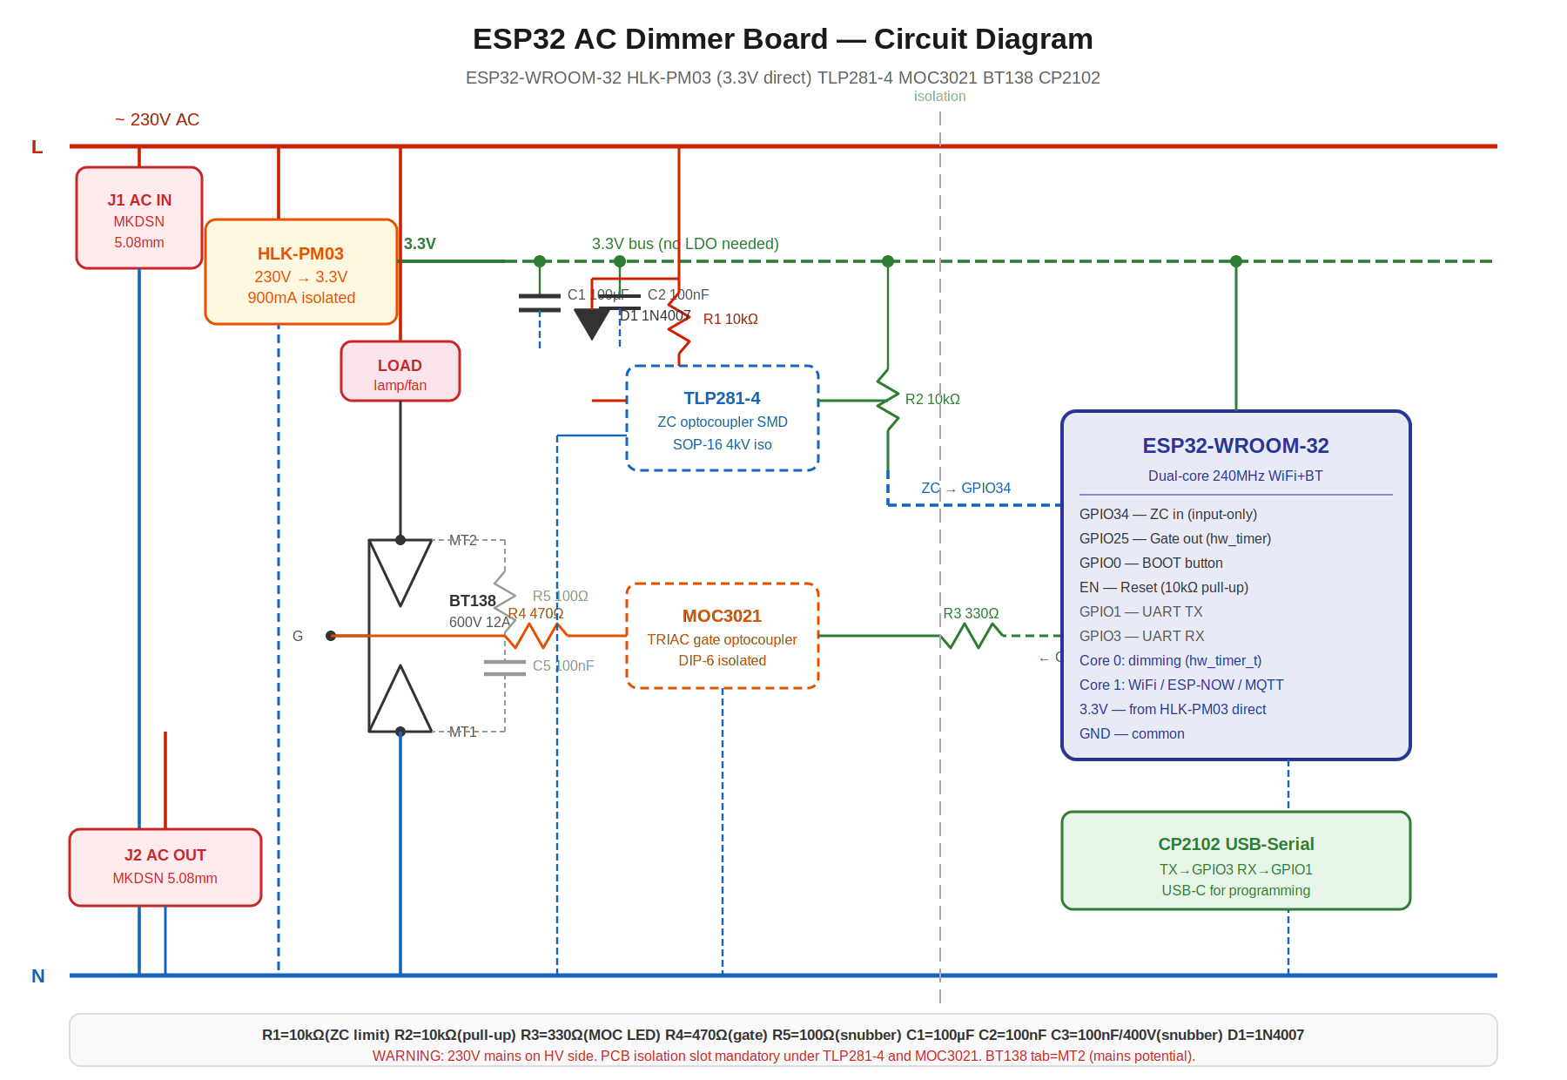
Figure 1 — ESP32 Dimmer Board. Red rails = 230V AC. Green dashed = 3.3V bus. Note: HLK-PM03 directly outputs 3.3V — no LDO between PSU and ESP32.

3.2 Remote board
The LiPo battery feeds the TP4056 charger (which also accepts USB-C input) and the ME6211 LDO simultaneously. The ME6211 regulates 3.7V to a clean 3.3V for the ESP32. Buttons use 100kOhm pull-ups (not 10kOhm) to minimise leakage current during deep sleep. All three button GPIOs (39, 34, 35) are RTC-capable and used with esp_sleep_enable_ext1_wakeup(). The CP2102 provides USB-C programming.

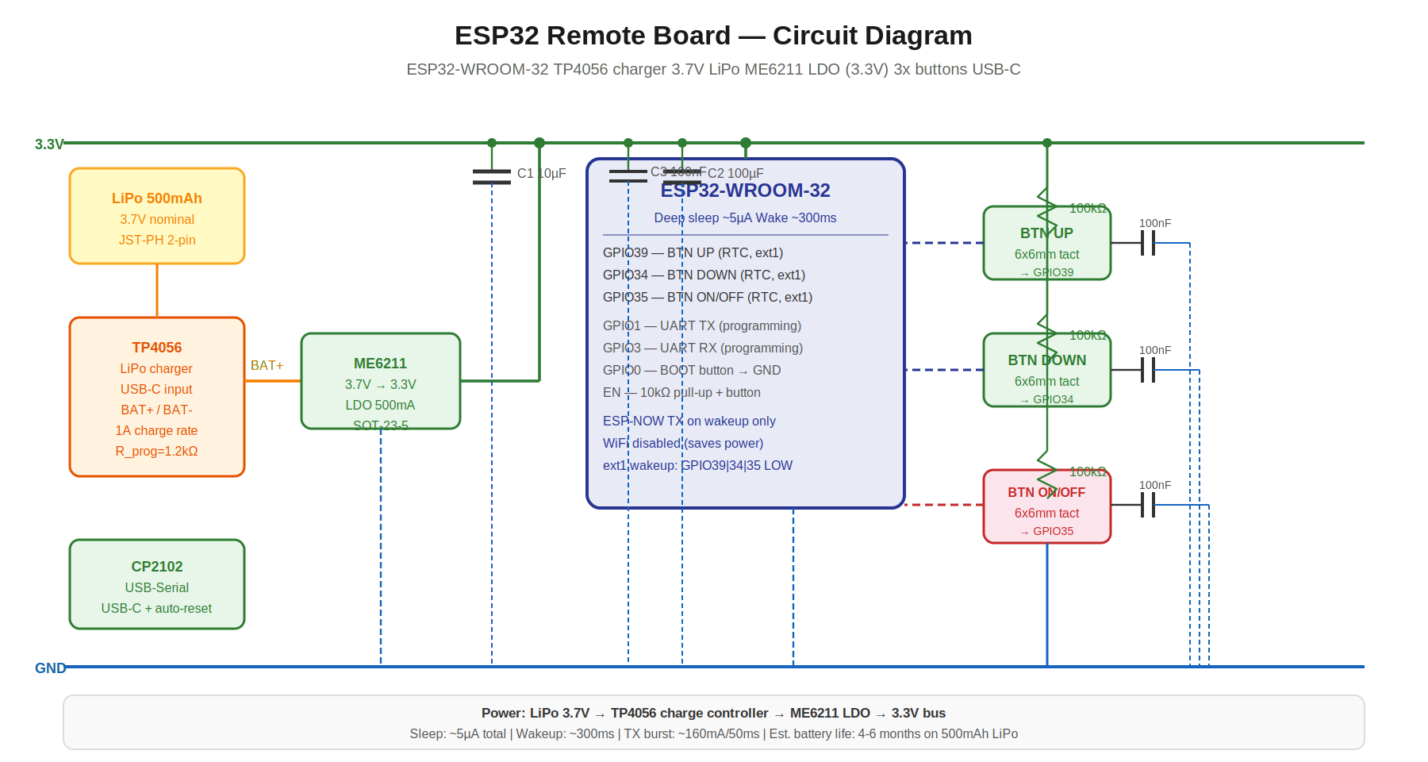
Figure 2 — ESP32 Remote Board. LiPo + TP4056 + ME6211 power chain. All button pins are RTC GPIOs for deep sleep ext1 wakeup.

4. Pin Mapping

4.1 Dimmer board — ESP32 GPIO assignments
GPIO | Signal | Direction | Notes
GPIO34 | ZC detect (TLP281-4 output) | Input only | Input-only RTC GPIO. No internal pull-up. Use external 10kOhm pull-up to 3.3V.
GPIO25 | TRIAC gate (MOC3021 LED via R3) | Output | DAC-capable but used as digital. hw_timer_t fires 100us pulse here.

4.2 Remote board — ESP32 GPIO assignments
GPIO | Signal | Direction | Notes
GPIO39 | BTN UP | Input only | RTC GPIO. Input-only. External 100kOhm pull-up to 3.3V. ext1 wakeup source.
GPIO34 | BTN DOWN | Input only | RTC GPIO. Input-only. External 100kOhm pull-up. ext1 wakeup source.
GPIO35 | BTN ON/OFF | Input only | RTC GPIO. Input-only. External 100kOhm pull-up. ext1 wakeup source.

Document prepared by Harsh | ESP32 IoT Dimmer Project v2.0 | March 2026

